**Skittles Speciation Lab** Name:

Period:

Date:

**Pre-Lab Questions:**

1. Define the word “species.” _________________________________________________ ________________________________________________________________________
2. What is speciation? ________________________________________________________________________________________________________________________________________________
3. What are the 5 ways species can become isolated and form new species?
   1. _______________________________________
   2. _______________________________________
   3. _______________________________________
   4. _______________________________________
   5. _______________________________________

**Introduction:** A species of beetles comes in a variety of colors (yellow, orange, red, purple, and green). These beetles are living together on a small island. We will observe what happens to the beetles as environmental pressures act on the population.

**Speciation Round 1:**

1. Remove the beetles from your cup and spread them out on the paper towel. The paper towel represents your island. How many total beetles do you have in your cup? ________ Record how many beetles you have of each color under Initial Population on data table 1. To calculate the percent of each color, divide the number by the total.

**Data Table 1**



|  |  |  |
| --- | --- | --- |
| **Color** | **Initial Population** | **Initial %** |
| Yellow |  |  |
| Red |  |  |
| Green |  |  |
| Orange |  |  |
| Purple |  |  |

1. Oh no! A large storm brings flood waters to the island. The water carves out a river that separates the population into two groups. With your pen, randomly draw a line separating your skittles into two groups. This line represents the river that the beetles can no longer cross. (Note: You don’t have to have the same number of skittles on each side of the river.)

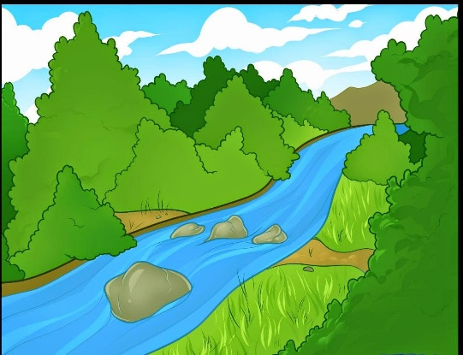

How many beetles are in group #1? __________

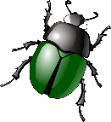

How many beetles are in group #2? __________

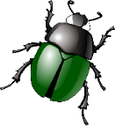Record how many beetles you have in each population in data table 2. Calculate the percent of each color by dividing by the new total number of skittles **in each** population.

**Data Table 2**

|  |  |  |  |  |
| --- | --- | --- | --- | --- |
| **Color** | **Group 1 Population** | **Group 1 %** | **Group 2 Population** | **Group 2 %** |
| Yellow |  |  |  |  |
| Red |  |  |  |  |
| Green |  |  |  |  |
| Orange |  |  |  |  |
| Purple |  |  |  |  |

1. What type of isolation occurred? ____________________________________________
2. How did the population change in group 1 compared to the initial population? ________________________________________________________________________________________________________________________________________________
3. How did the population change in group 2 compared to the initial population? ________________________________________________________________________________________________________________________________________________

**Speciation Round 2:**

1. On the side of the river where group 1 lives, there are a lot of grassy areas. Which color beetle will survive best in this habitat? Explain. ________________________________________________________________________________________________________________________________________________
2. On the side of the river where group 2 lives, there are a lot of sandy areas. Which color beetle will survive best in this habitat? Explain ________________________________________________________________________________________________________________________________________________
3. As a predator, you will spot the beetles easily that aren’t able to camouflage. In group 1, you may eat 3 of each color (if available) **except the green beetles**. In group 2, you may eat 3 of each color (if available) **except the yellow beetles**.

How many total beetles are left in group 1? __________

How many total beetles are left in group 2? __________

Record how many you have of each color and calculate the percent by dividing by the new total number of skittles **in each** population. Record in table 3.

**Data Table 3**

|  |  |  |  |  |
| --- | --- | --- | --- | --- |
| **Color** | **Group 1 Population** | **Group 1 %** | **Group 2 Population** | **Group 2 %** |
| Yellow |  |  |  |  |
| Red |  |  |  |  |
| Green |  |  |  |  |
| Orange |  |  |  |  |
| Purple |  |  |  |  |

1. What type of isolation occurred? _______________________________
2. How did the population change in group 1 compared to the initial population? ________________________________________________________________________________________________________________________________________________
3. How did the population change in group 2 compared to the initial population? ________________________________________________________________________________________________________________________________________________
4. Suppose in 100 years the beetles in group 1 come back into contact with the beetles in group 2. Do you think they will be able to reproduce with each other or will they be separate species? Explain. ________________________________________________________________________________________________________________________________________________________________________________________________________________________

Once you finish the questions you may eat the rest of your skittles ☺

**Answer Key**

**Pre-Lab Questions**

1. A species is a group of organisms so similar to one another that they can breed and produce fertile offspring.
2. Speciation is the evolution of two or more species from one ancestral species.
3. The 5 forms of isolation that can lead to speciation are: temporal, behavioral, geographic, reproductive, and ecological.

**Part 1:**

1. Answers will vary (see teacher notes to see how many total skittles I typically use).
2. Answers will vary.
3. Geographic isolation
4. Answers will vary. Students might say things like “the orange population increased, and the green population decreased…”
5. Answers will vary. Students might say things like “the orange population increased, and the green population decreased…”

**Part 2:**

1. Green will survive better than the other colors because it is better at camouflaging with the grass.
2. Yellow will survive better than the other colors because it is better at camouflaging with the sand.
3. Answers will vary.
4. Ecological isolation
5. Answers may vary, but the green population should have increased compared to the others.
6. Answers may vary, but the yellow population should have increased compared to the others.
7. After 100 years, the beetles will still be able to reproduce. It usually takes a much longer period of time for speciation to occur (depending on the species, it could take thousands to millions of years).

**Teacher Notes:**

* Group students in groups of 3-4. Each group will get a paper towel and a dixie cup full of skittles.
* 3 large bags of skittles is usually enough for 5 class periods. I give students around 40 skittles to start with in their dixie cup.
* If you buy less skittles, in step 8 have the students only eat 2 skittles of each color instead of 3.

Thank you for your purchase! Check out my other evolution products here:

<https://www.teacherspayteachers.com/Store/Science-Rocks/Category/Evolution-203275>

Don’t forget that by leaving feedback you can receive TpT credits that can be redeemed for future purchases.



Copyright ©2017 Science Rocks

All rights reserved by author.

Permission to copy for single classroom use only.

Electronic distribution limited to single classroom use only.

Not for public display.